**POWDERS**

**HERO**

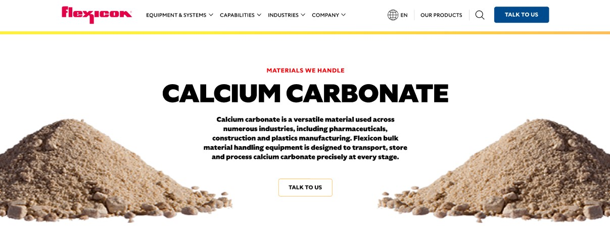

Powders are used across a wide range of industries, from food and pharmaceuticals to chemicals and construction. Flexicon bulk material handling equipment is designed to convey, store, and process powders with precision and care.

**Button**: Talk To Us

**SHELF #1 - PRODUCT DESCRIPTION**

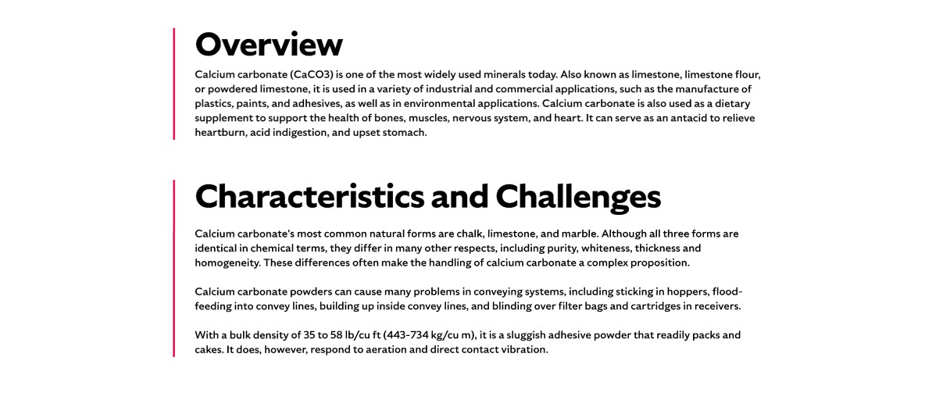

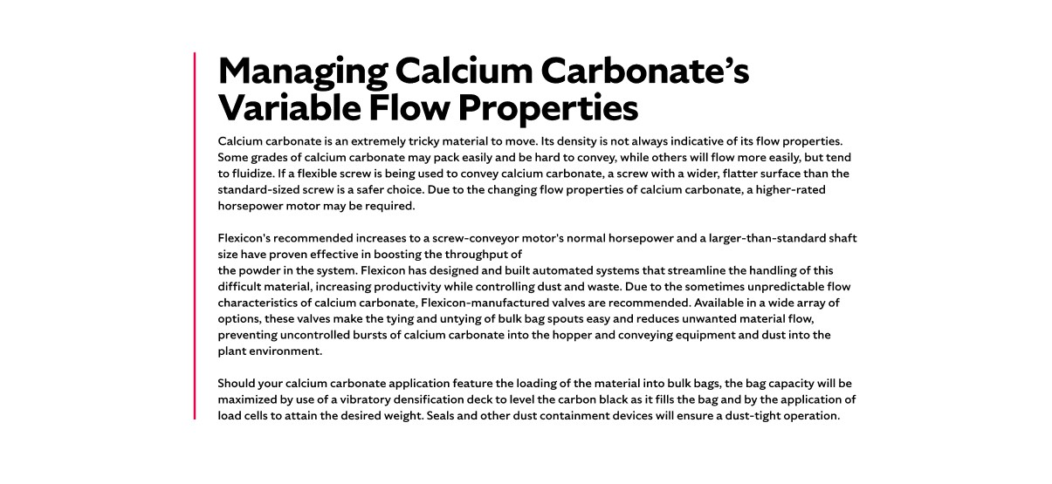

**Overview**Powders encompass a broad category of dry organic and inorganic materials, typically formed through crushing, grinding, atomization, or other size reduction methods. They are essential in the production of everyday goods such as drink mixes, dairy products, vitamins, ceramics, cosmetics, and batteries. Powder handling is critical in industries like food, pharmaceuticals, chemicals, and paints, where consistency, cleanliness, and efficiency are paramount. Flexicon systems are engineered to manage powders reliably, whether free-flowing or difficult-to-handle, while minimizing dust and maintaining product integrity.

**Characteristics and Challenges**Powder flow characteristics are influenced by bulk density, particle size, shape, and cohesiveness. Blends of powders with varying properties can behave unpredictably, especially when exposed to moisture, temperature changes, vibration, or incompatible materials. These conditions may cause powders to aerate, fluidize, agglomerate, or degrade. Certain powders like flour or hydrated lime may bridge or rat-hole, while light powders such as fumed silica or talc can blind filters and escape into the environment. Others, like carbon black and titanium dioxide, are prone to packing and smearing, which can jam equipment and require extensive cleanup. Fat-rich powders like milk powder may leave residue in conveying lines, increasing contamination risks. Abrasive powders like micronized salt or sand can damage equipment, and blends with disparate particle sizes may separate, reducing product quality.

Dust generation is a major concern during powder handling, as it can contaminate the environment, pose health risks, and increase the potential for combustion or explosion. Regulatory bodies like OSHA classify dust as a key element in explosion risk, prompting strict containment requirements. Some powders are water-reactive, releasing heat or toxic gases upon contact with moisture, while others agglomerate and alter flow behavior. Flexicon addresses these challenges with dust-tight equipment and sealed connections to prevent dust escape and moisture intrusion. Bulk Bag Dischargers and Fillers feature secure seals and flow promotion devices to ensure clean, efficient transfer. Manual and container dumping stations incorporate dust collection systems to protect workers and maintain cleanliness. Conveying systems are selected based on powder characteristics, with vacuum pneumatic systems recommended for toxic powders to contain leaks and enhance safety.

**SHELF #2 - FLEXICON SOLUTIONS**

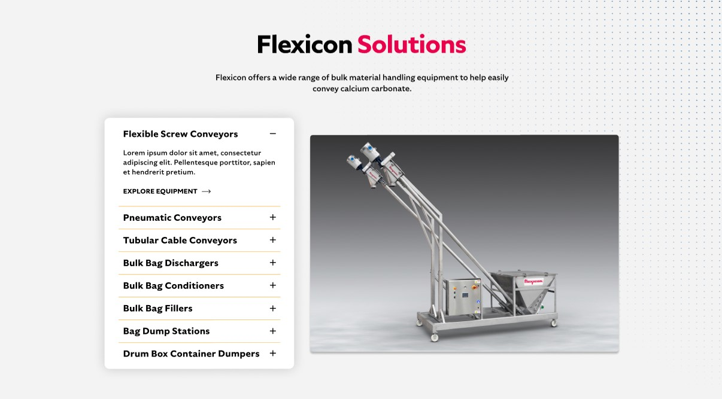

**Flexicon Solutions**

Flexicon offers a wide range of bulk material handling equipment to help easily convey powders.

**Flexible Screw Conveyors:** Deliver consistent flow of powders that tend to clump, aerate, or separate, using a gentle conveying action.

**Pneumatic Conveyors:** Move powders through enclosed pipelines with high efficiency, while minimizing airborne dust and maintaining hygiene.

**Tubular Cable Conveyors:** Transport powders smoothly through tight layouts with enclosed, low-impact handling that protects product quality.

**Bulk Bag Dischargers:** Discharge powders from bulk bags securely, using sealing and flow-assist features to reduce dust and manual effort.

**Bulk Bag Conditioners:** Break up hardened powders inside bulk bags to restore flowability and ensure uninterrupted discharge.

**Bulk Bag Fillers:** Load powders into bulk bags with precision, using vibration and weighing systems to optimize fill and reduce spillage.

**Bag Dump Stations:** Enable safe manual unloading of powders with integrated dust control and ergonomic design for operator comfort.

**Drum/Box/Container Dumpers:** Empty powders from smaller containers into processing systems with minimal dust release and reduced labor.

**SHELF #3: LIFETIME PERFORMANCE GUARANTEE**

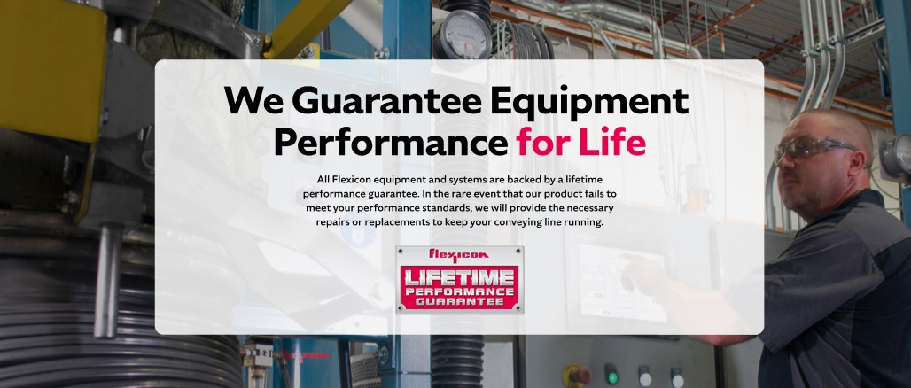

**Lifetime Performance Guarantee**

All Flexicon equipment and systems are backed by a lifetime performance guarantee. In the rare event that our product fails to meet your performance standards, we will provide the necessary repairs or replacements to keep your conveying line running.

**SHELF #4: CASE STUDIES**

